ASSIGNMENT -1

Name :M.Vyshnavi
Hall ticket :2303A54068
Batch :48

Task 1: AI-Generated Logic Without Modularization (Fibonacci Sequence Without Functions)

- Scenario
You are asked to write a quick numerical sequence generator for a learning platform prototype.

- Task Description
Use GitHub Copilot to generate a Python program that:
  - Prints the Fibonacci sequence up to n terms
  - Accepts user input for n
  - Implements the logic directly in the main code
  - Does not use any user-defined functions

- Expected Output
  - Correct Fibonacci sequence for given n
  - Screenshot(s) showing Copilot-generated suggestions
  - Sample inputs and outputs
CODE:
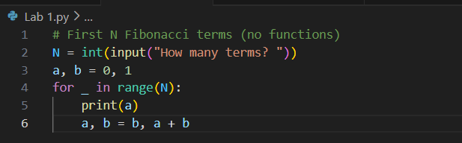

OUTPUT:

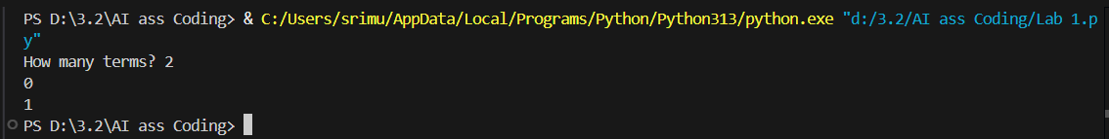

PROMPT :
Give me the python code for fibonacci sequence without functions
CODE EXPLANATION :
This program prints the first N Fibonacci numbers without using functions. It first takes the number of terms (N) from the user. Then it initializes two variables a and b with values 0 and 1. A for loop runs N times, printing the current value of a each time. After printing, the values of a and b are updated so that a becomes the next Fibonacci number and b stores the following one. This loop-based approach is simple, fast, and easy to understand.

Task 2: AI Code Optimization & Cleanup (Improving Efficiency)

- Scenario
The prototype will be shared with other developers and needs optimization.

- Task Description
  - Examine the Copilot-generated code from Task 1 and improve it by:
  - Removing redundant variables
  - Simplifying loop logic
  - Avoiding unnecessary computations
  - Use Copilot prompts such as:
    - “Optimize this Fibonacci code”
    - “Simplify variable usage”

Hint:
Prompt Copilot with phrases like
“optimize this code”, “simplify logic”, or “make it more readable”

- Expected Output
  - Original vs improved code
  - Written explanation of:
    - What was inefficient
    - How the optimized version improves performance and readability

CODE AND OUTPUT :

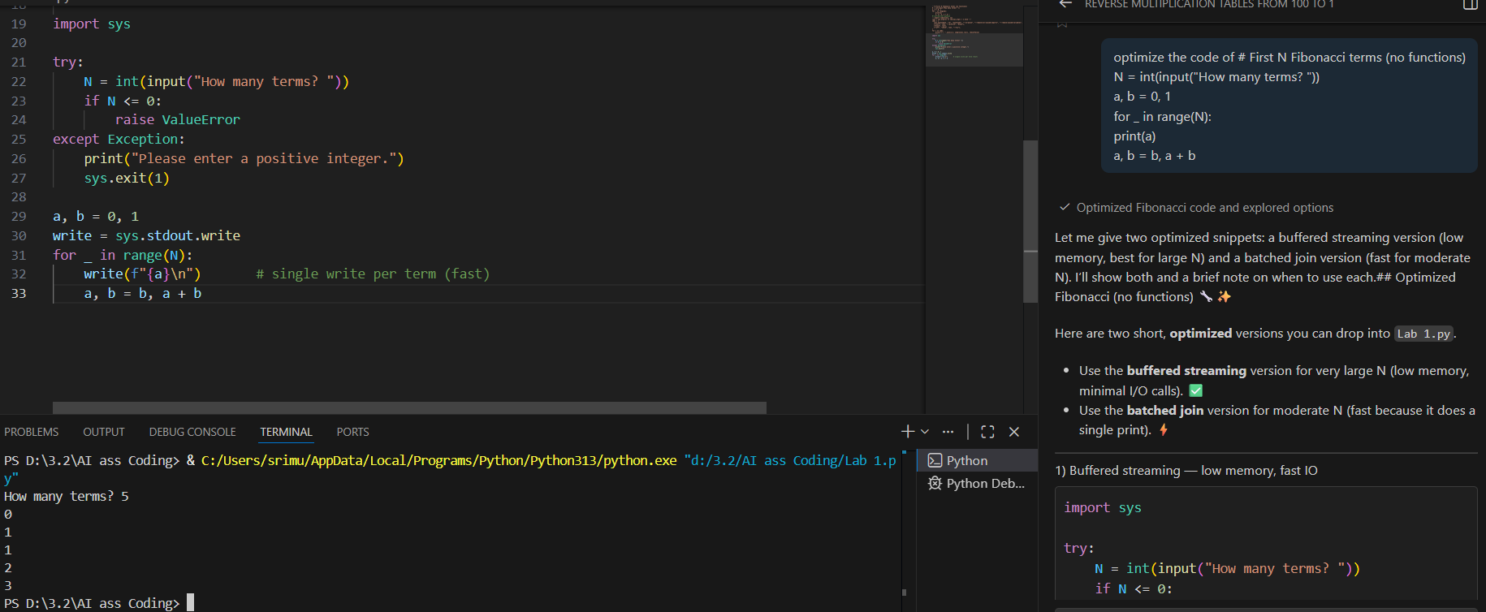

PROMPT:
Optimize the above code
CODE EXPLANATION :
This program prints the first N Fibonacci numbers in an optimized way without using functions. It first takes input from the user and checks whether the value is a positive integer using a try–except block. If the input is invalid, it displays an error message and exits the program. After validation, it initializes the first two Fibonacci numbers (a = 0 and b = 1). A loop then runs N times, printing each Fibonacci number using sys.stdout.write, which is faster than normal printing. After each output, the values are updated to generate the next Fibonacci number. This approach is efficient and suitable for larger inputs.

Task-3: Modular Design Using AI Assistance (Fibonacci Using Functions)

- Scenario
The Fibonacci logic is now required in multiple modules of an application.

- Task Description
Use GitHub Copilot to generate a function-based Python program that:
  - Uses a user-defined function to generate Fibonacci numbers
  - Returns or prints the sequence up to n
  - Includes meaningful comments (AI-assisted)

- Expected Output
  - Correct function-based Fibonacci implementation
  - Screenshots documenting Copilot’s function generation
Sample test cases with outputs
CODE:

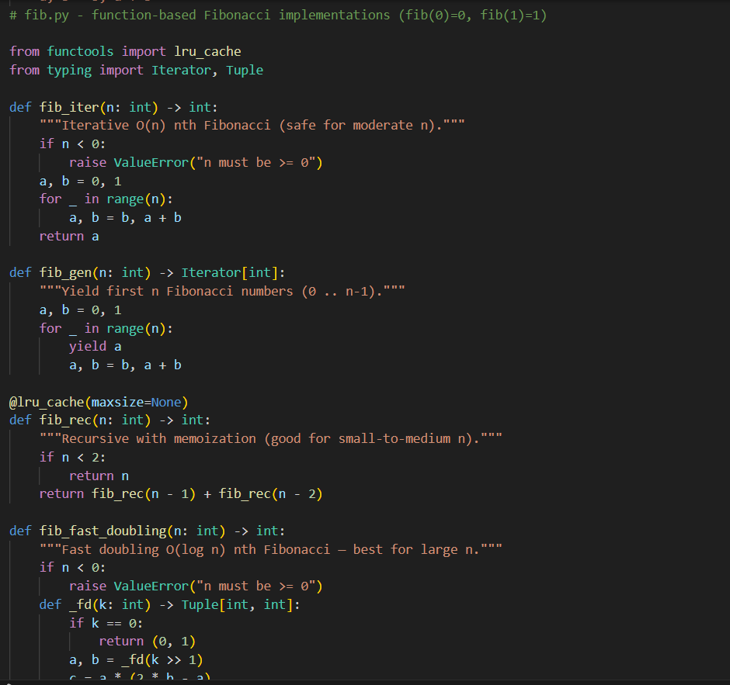

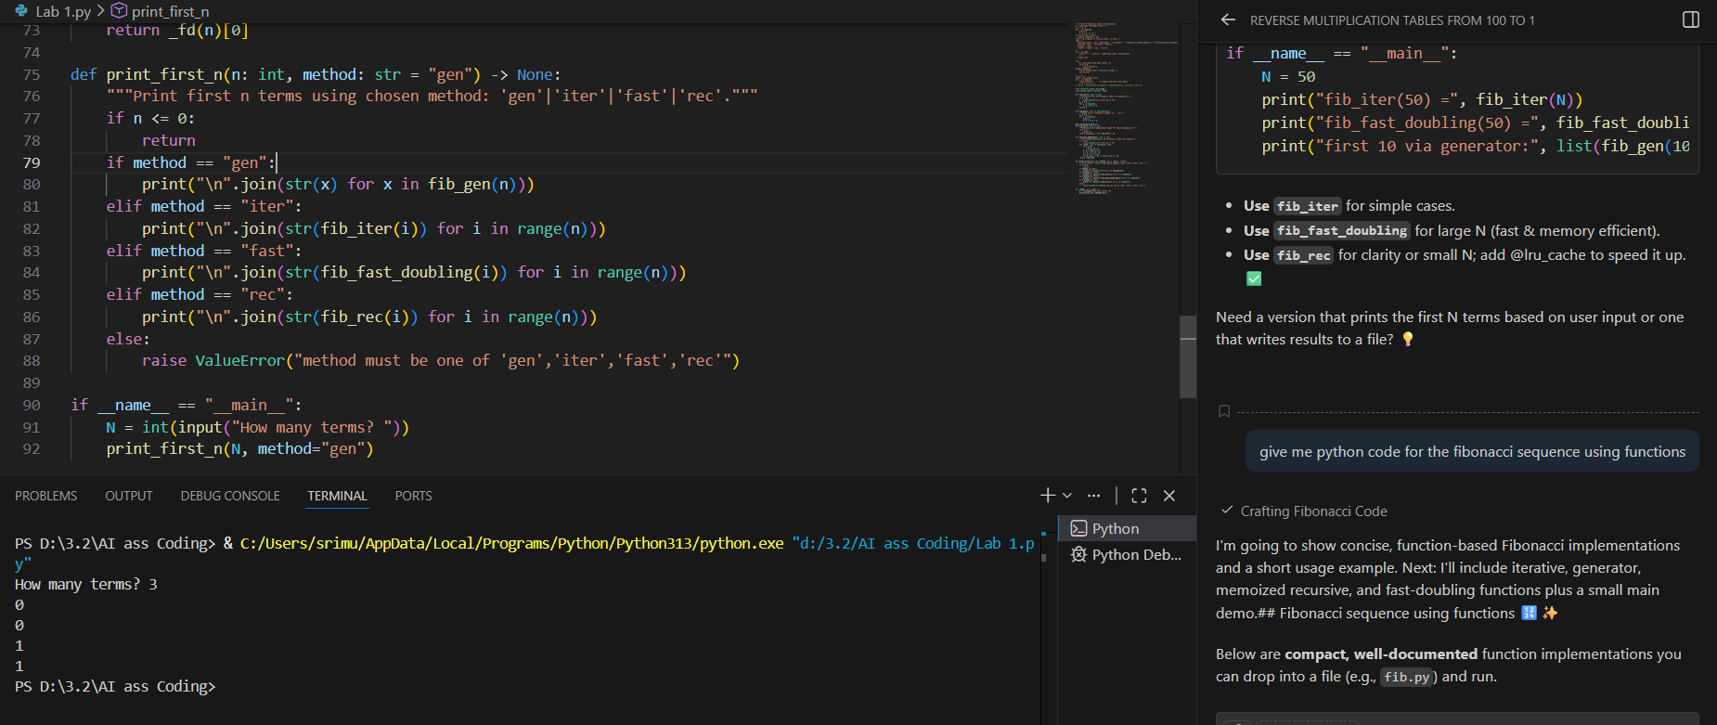
OUTPUT:

PROMPT:
Give me python code for the fibonacci sequence using function
CODE EXPLANATION :
This code uses functions to generate Fibonacci numbers in different efficient ways. It includes an iterative method, a generator for memory efficiency, a recursive method with memoization for clarity, and a fast-doubling method for very large inputs. A common print function lets the user choose any method, making the code reusable, organized, and suitable for larger programs.

Task 4: Comparative Analysis – Procedural vs Modular Fibonacci Code

- Scenario
You are participating in a code review session.

- Task Description
Compare the Copilot-generated Fibonacci programs:
  - Without functions (Task 1)
  - With functions (Task 3)
  - Analyze them in terms of:
    - Code clarity
    - Reusability
    - Debugging ease
    - Suitability for larger systems

- Expected Output
Comparison table or short analytical report

CODE:
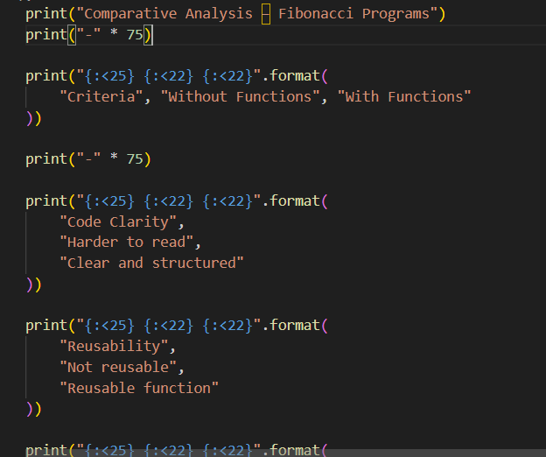
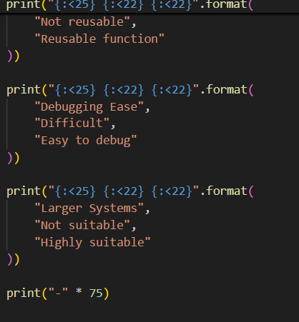
OUTPUT:
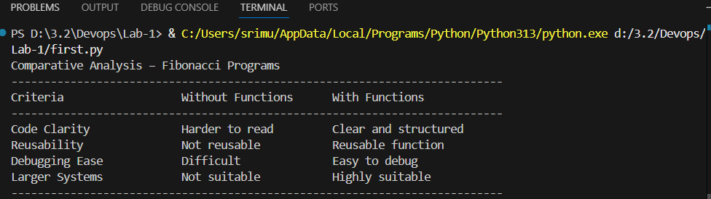
PROMPT:
Iam participating in a code review session compare fibonacci sequence without functions and with function analyze them in terms of code clarity and ressability and debugging ease and suitability for larger systems

CODE EXPLANATION :
This code prints a comparison table in a clean and readable format using Python’s format() method. Each print statement displays one row with properly aligned columns, making the data easy to compare. The values show differences like reusability, debugging ease, and suitability for large systems. The line printed using "-" * 75 acts as a separator to improve table readability.

Task 5: AI-Generated Iterative vs Recursive Fibonacci Approaches (Different Algorithmic Approaches for Fibonacci Series)

- Scenario
Your mentor wants to assess AI’s understanding of different algorithmic paradigms.

- Task Description
Prompt GitHub Copilot to generate:
An iterative Fibonacci implementation
A recursive Fibonacci implementation

- Expected Output
  - Two correct implementations
  - Explanation of execution flow for both
  - Comparison covering:
    - Time and space complexity
    - Performance for large n
    - When recursion should be avoided
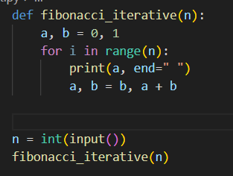

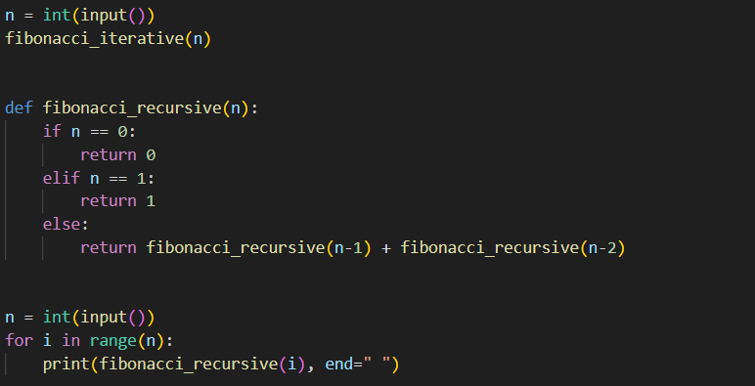
PROMPT :

Give me the code for Iterative vs Recursive Fibonacci Approaches Different Algorithmic Approaches for Fibonacci Series
CODE EXPLANATION :
Iterative Fibonacci uses a loop to generate Fibonacci numbers one by one by updating variables. It is fast, uses less memory, and works well for large values of n. Recursive Fibonacci uses a function that calls itself to calculate Fibonacci numbers based on previous values. It is easy to understand but slow and uses more memory due to repeated function calls. Therefore, iterative Fibonacci is preferred for performance, while recursion is mainly used for learning concepts.

